**References**

American College of Emergency Physicians (2018). *Definition of Boarded Patient.* Policy Statements. <https://www.acep.org/patient-care/policy-statements/definition-of-boarded-patient/>

Aquino, et al. (2018). *descr: Descriptive Statistics*. R package version 1.1.4. <https://CRAN.R-project.org/package=descr>

Artiga, S., Orgera, K., & Damico, A. (2020). *Changes in Health Coverage by Race and Ethnicity since the ACA, 2010-2018*. <https://www.kff.org/disparities-policy/issue-brief/changes-in-health-coverage-by-race-and-ethnicity-since-the-aca-2010-2018/>

Braveman, P., & Barclay, C. (2009). Health Disparities Beginning in Childhood: A Life-Course Perspective. *Pediatrics, 124*(Supplement 3), S163–S175. <https://doi.org/10.1542/peds.2009-1100d>

Cambridge Dictionary (n.d.) Inpatient. In *Cambridge Academic Content Dictionary*. Retrieved from <https://dictionary.cambridge.org/us/dictionary/english/inpatient>

Carron, P.-N., Yersin, B., Trueb, L., Gonin, P., & Hugli, O. (2014). Missed Opportunities: Evolution of Patients Leaving without Being Seen or against Medical Advice during a Six-Year Period in a Swiss Tertiary Hospital Emergency Department. *BioMed Research International, 2014*(1–8). <https://doi.org/10.1155/2014/690368>

Cecil G. Sheps Center for Health Services Research. (2019). *U.S. Hospital List* [XLSX]. Available from <https://www.shepscenter.unc.edu/programs-projects/rural-health/data/>

Centers for Medicare & Medicaid Services. (2019). *Hospital Service Area File*. (May 2019 Update)[CSV]. Available from <https://www.cms.gov/Research-Statistics-Data-and-Systems/Statistics-Trends-and-Reports/Hospital-Service-Area-File>

Centers for Medicare & Medicaid Services. (2019-2020). *Hospital Compare*. (Oct 2019 & Jul 2020 Updates)[CSV]. Available from <https://data.medicare.gov/data/archives/hospital-compare>

Cribari-Neto, F. & Zeileis, A. (2010). Beta Regression in R. *Journal of Statistical Software 34*(2), 1-24. <http://www.jstatsoft.org/v34/i02/>

Feng, C., Wang, H., Lu, N., Chen, T., He, H., Lu, Y., & Tu, X. M. (2014). Log-transformation and its implications for data analysis. *Shanghai Archives of Psychiatry, 26*(2), 105–109. <https://doi.org/10.3969/j.issn.1002-0829.2014.02.009>

Flores, G. (2010). Racial and Ethnic Disparities in the Health and Health Care of Children. *PEDIATRICS, 125*(4), e979–e1020. <https://doi.org/10.1542/peds.2010-0188>

Fox, J. & Weisberg, S. (2019). *car: An R Companion to Applied Regression, Third Edition*. Sage Publishing.

Garfield, R., Orgera, K. & Damico, A. (2020). *The Coverage Gap: Uninsured Poor Adults in States that Do Not Expand Medicaid*. Kaiser Family Foundation. <https://www.kff.org/medicaid/issue-brief/the-coverage-gap-uninsured-poor-adults-in-states-that-do-not-expand-medicaid/>

Georgetown University Health Policy Institute. (n.d.). *Rural and Urban Health*. <https://hpi.georgetown.edu/rural/>

Goyal, M. K., Kuppermann, N., Cleary, S. D., Teach, S. J., & Chamberlain, J. M. (2015). Racial Disparities in Pain Management of Children With Appendicitis in Emergency Departments. *JAMA Pediatrics, 169*(11), 996. <https://doi.org/10.1001/jamapediatrics.2015.1915>

Haywood, C., Jr., Tanabe, P., Naik, R., Beach, M. C., & Lanzkron, S. (2013). The impact of race and disease on sickle cell patient wait times in the emergency department*. The American Journal of Emergency Medicine, 31*(4), 651–656. <https://doi.org/10.1016/j.ajem.2012.11.005>

Himmelstein, D. U., & Woolhandler, S. (2016). The Current and Projected Taxpayer Shares of US Health Costs*. American Journal of Public Health, 106*(3), 449–452. <https://doi.org/10.2105/ajph.2015.302997>

Hsia, R. Y., Asch, S. M., Weiss, R. E., Zingmond, D., Liang, L.-J., Han, W., McCreath, H., & Sun, B. C. (2011). Hospital Determinants of Emergency Department Left Without Being Seen Rates. *Annals of Emergency Medicine, 58*(1), 24-32.e3. <https://doi.org/10.1016/j.annemergmed.2011.01.009>

Jacobs, E. A., Rolle, I., Ferrans, C. E., Whitaker, E. E., & Warnecke, R. B. (2006). Understanding African Americans’ views of the trustworthiness of physicians. *Journal of General Internal Medicine, 21*(6), 642–647. <https://doi.org/10.1111/j.1525-1497.2006.00485.x>

Kaiser Family Foundation. (2020). *Status of State Action on the Medicaid Expansion Decision*. <https://www.kff.org/health-reform/state-indicator/state-activity-around-expanding-medicaid-under-the-affordable-care-act/>

Lee, H. H., Lewis, C. W., & McKinney, C. M. (2016). Disparities in Emergency Department Pain Treatment for Toothache. *JDR Clinical & Translational Research, 1*(3), 226–233. <https://doi.org/10.1177/2380084416655745>

Lüdecke, D. (2020). *sjPlot: Data Visualization for Statistics in Social Science*. R package version 2.8.4. <https://CRAN.R-project.org/package=sjPlot>

Medicaid (2020). *About Medicaid.* Center for Medicare and Medicaid Services. <https://www.medicaid.gov/medicaid/index.html>

Medicare (n.d.) *What’s Medicare?* Medicare.gov, The Official U.S. Government Site for Medicare. <https://www.medicare.gov/what-medicare-covers/your-medicare-coverage-choices/whats-medicare>

Merriam-Webster. (n.d.). Zip-code. In *Merriam-Webster.com dictionary*. Retrieved from https://www.merriam-webster.com/dictionary/zip-code

National Center for Health Statistics. (2018). *National Ambulatory Medical Care Survey 2018 Patient Record Card*. <https://www.cdc.gov/nchs/data/ahcd/2018_NAMCS_Patient_Record_Sample_Card.pdf>

National Rural Health Association (n.d.) *About Rural Health Care*. Rural Information Health Hub. <https://www.ruralhealthweb.org/about-nrha/about-rural-health-care>

Nelder, J. A., & Wedderburn, R. W. M. (1972). Generalized Linear Models. *Journal of the Royal Statistical Society. Series A (General), 135*(3), 370. <https://doi.org/10.2307/2344614>

Neuwirth, E. (2014). *RColorBrewer: ColorBrewer Palettes*. R package version 1.1-2. <https://CRAN.R-project.org/package=RColorBrewer>

Okunseri, C., Okunseri, E., Chilmaza, C. A., Harunani, S., Xiang, Q., & Szabo, A. (2013). Racial and ethnic variations in waiting times for emergency department visits related to nontraumatic dental conditions in the United States. *Journal of the American Dental Association (1939), 144(*7), 828–836. <https://doi.org/10.14219/jada.archive.2013.0195>

Pines, J. M., Russell Localio, A., & Hollander, J. E. (2009). Racial Disparities in Emergency Department Length of Stay for Admitted Patients in the United States. *Academic Emergency Medicine, 16*(5), 403–410. <https://doi.org/10.1111/j.1553-2712.2009.00381.x>

Plunkett, P. K., Byrne, D. G., Breslin, T., Bennett, K., & Silke, B. (2011). Increasing wait times predict increasing mortality for emergency medical admissions. *European Journal of Emergency Medicine, 18*(4), 192–196. <https://doi.org/10.1097/mej.0b013e328344917e>

R Core Team (2017). *R: A language and environment for statistical computing*. R Foundation for Statistical Computing. <https://www.R-project.org/>

Richardson, D. B. (2006). Increase in patient mortality at 10 days associated with emergency department overcrowding. *Medical Journal of Australia, 184*(5), 213–216. <https://doi.org/10.5694/j.1326-5377.2006.tb00204.x>

RStudio Team (2020). RStudio: Integrated Development for R. RStudio, PBC, Boston, MA. Available from http://www.rstudio.com/

Saha, S., Taggart, S. H., Komaromy, M., & Bindman, A. B. (2000). Do Patients Choose Physicians Of Their Own Race? *Health Affairs, 19*(4), 76–83. <https://doi.org/10.1377/hlthaff.19.4.76>

Shaikh, S., Jerrard, D., Witting, M., Winters, M., & Brodeur, M. (2012). How Long Are Patients Willing to Wait in the Emergency Department Before Leaving Without Being Seen. *Western Journal of Emergency Medicine, 13*(6), 463–467. <https://doi.org/10.5811/westjem.2012.3.6895>

Shiel, W. C. (2018). *Medical Definition of Emergency Department*. Medicine Net. <https://www.medicinenet.com/script/main/art.asp?articlekey=12156>

Singh, G. K., & Siahpush, M. (2014). Widening Rural–Urban Disparities in Life Expectancy, U.S., 1969–2009. *American Journal of Preventive Medicine, 46*(2), e19–e29. <https://doi.org/10.1016/j.amepre.2013.10.017>

Tamayo-Sarver, J. H., Hinze, S. W., Cydulka, R. K., & Baker, D. W. (2003). Racial and Ethnic Disparities in Emergency Department Analgesic Prescription. *American Journal of Public Health, 93*(12), 2067–2073. <https://doi.org/10.2105/ajph.93.12.2067>

United States Census Bureau. (2018). *American Community Survey*. (2018 Version)[CSV]. Available from <https://data.census.gov/cedsci/table?g=0100000US.860000&tid=ACSDP5Y2018.DP05>

United States Office of Rural Health Policy. (2019). *FORHP Eligible ZIP Codes* [XLS]. Available from <https://www.hrsa.gov/rural-health/about-us/definition/datafiles.html>

Valuates Reports (2019). *Healthcare Analytics Market Report*. 360i Research. <https://reports.valuates.com/market-reports/360I-Auto-0U39/global-healthcare-analytics-market>

Venables, W. N. & Ripley, B. D. (2002). *Modern Applied Statistics with S. Fourth Edition*. Springer Publishing.

Vermeulen, M. J., Stukel, T. A., Guttmann, A., Rowe, B. H., Zwarenstein, M., Golden, B., Nigam, A., Anderson, G., Bell, R. S., Schull, M. J., Afilalo, M., Anderson, G., Bell, R. S., Carew, D., Carter, M., Cooke, M., Golden, B., Guttmann, A., Nigam, A., … Zwarenstein, M. (2014). Evaluation of an Emergency Department Lean Process Improvement Program to Reduce Length of Stay. *Annals of Emergency Medicine, 64*(5), 427–438. <https://doi.org/10.1016/j.annemergmed.2014.06.007>

Wickham, H. & Bryan, J. (2019). *readxl: Read Excel Files*. R package version 1.3.1. <https://CRAN.R-project.org/package=readxl>

Wickham, et al. (2019). Welcome to the tidyverse. *Journal of Open Source Software, 4*(43), 1686. <https://doi.org/10.21105/joss.01686>

Willoughby, K. A., Chan, B. T. B., & Strenger, M. (2010). Achieving wait time reduction in the emergency department. *Leadership in Health Services, 23*(4), 304–319. <https://doi.org/10.1108/17511871011079010>

Wilson, S., Dev, S., Mahan, M., Malhotra, M., & Miller, J. (2016). Identifying disparity in emergency department length of stay and admission likelihood. *World Journal of Emergency Medicine, 7*(2), 111–116. <https://doi.org/10.5847/wjem.j.1920-8642.2016.02.005>

Xie, Y. (2015). *Dynamic Documents with R and knitr: 2nd Edition*. Chapman and Hall.

Zhang, X., Carabello, M., Hill, T., He, K., Friese, C. R., & Mahajan, P. (2019). Racial and Ethnic Disparities in Emergency Department Care and Health Outcomes Among Children in the United States. *Frontiers in Pediatrics, 7*. <https://doi.org/10.3389/fped.2019.00525>

**Appendix**

**TABLE A-1: Averages by State for Length of Stay, Wait Time, LWBS Rate and Hospital Rating**

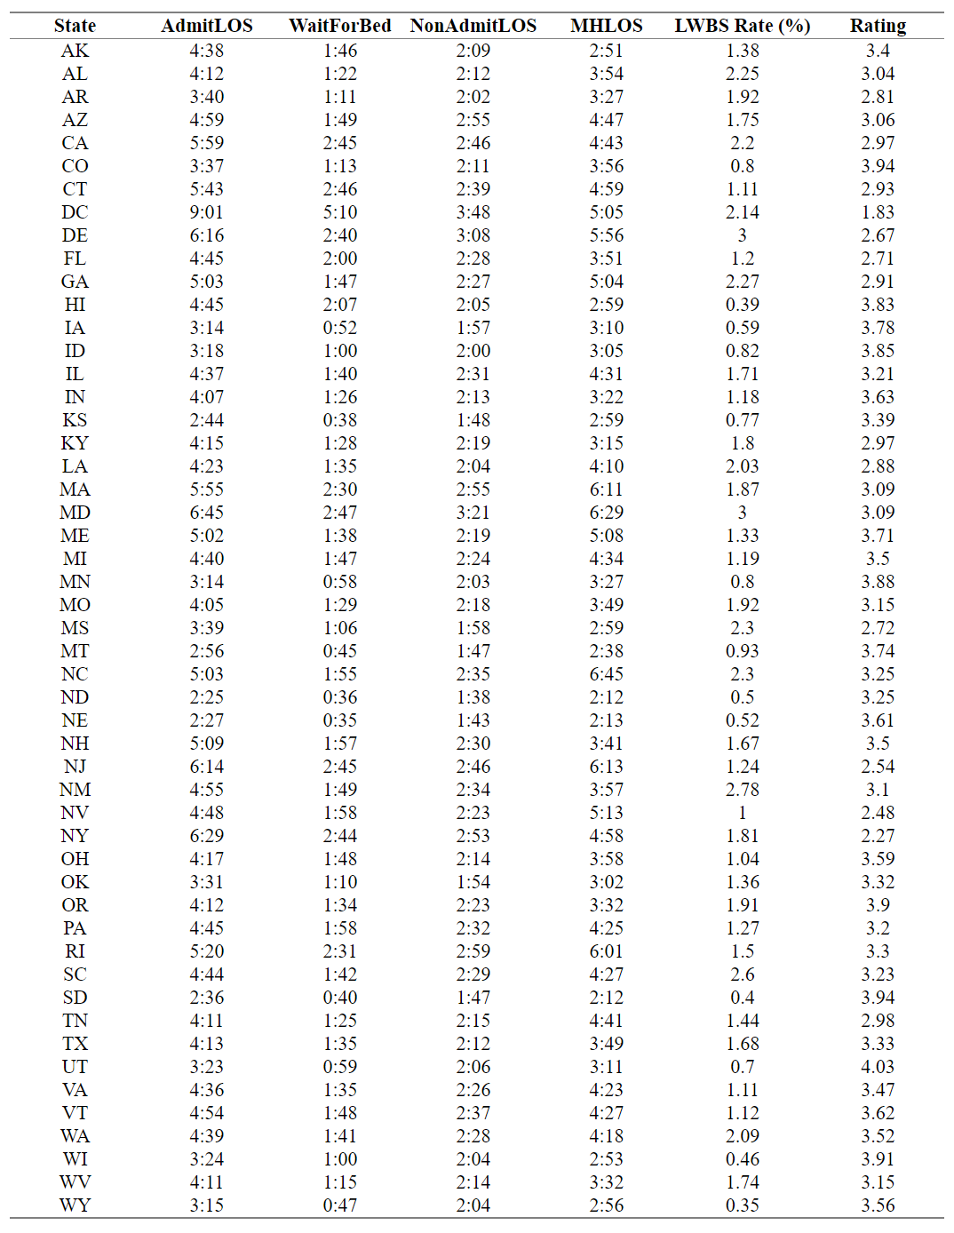

**TABLE A-2: Correlation Coefficients for all Pairwise Combinations of Continuous Variables**

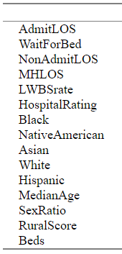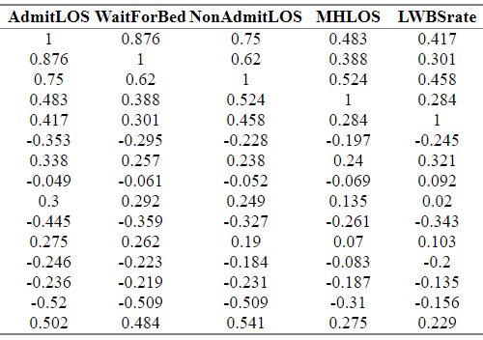

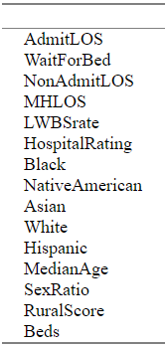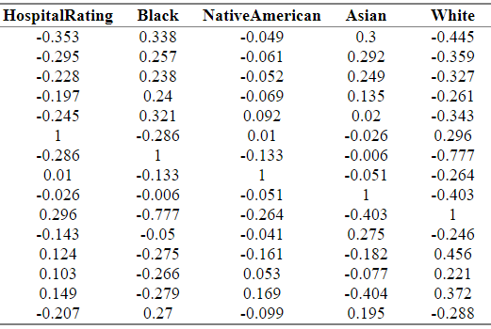

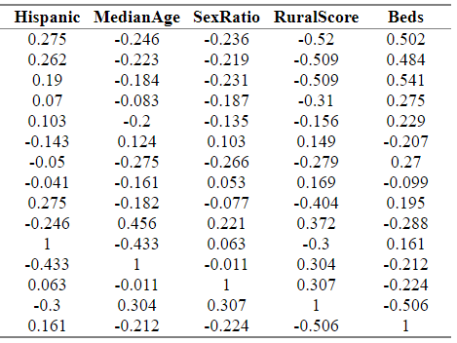

**FIGURES A-1 to A-5: Charts of Missing Data Rates by Race/Ethnicity and by Hospital Size/Location**

Short paragraph here about results?

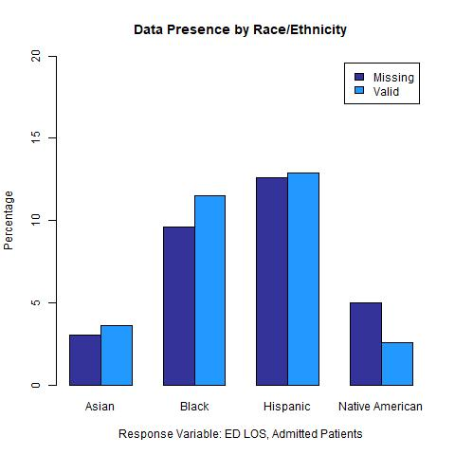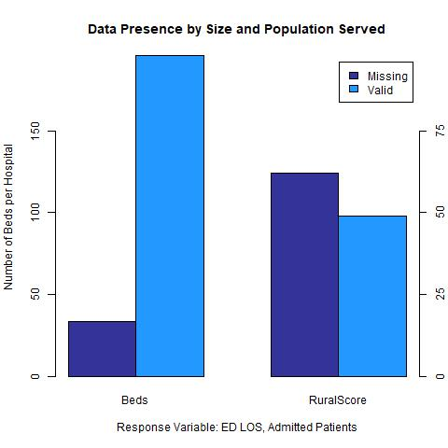

**FIGURE A-1: Rates of Missing Data for *AdmitLOS***

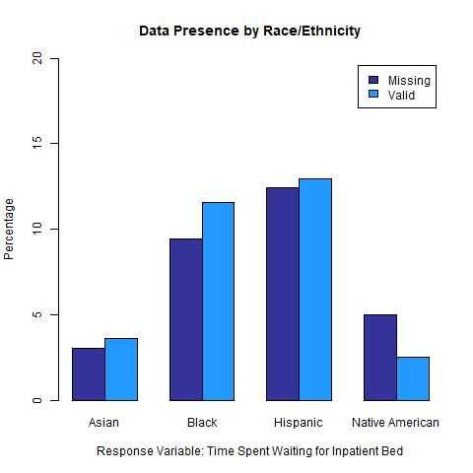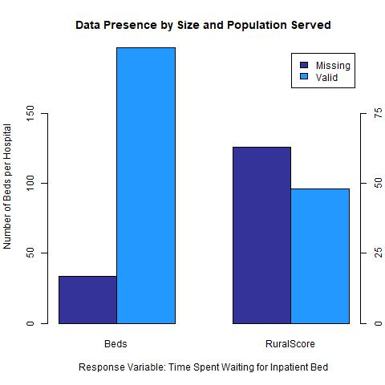

**FIGURE A-2: Rates of Missing Data for *WaitForBed***

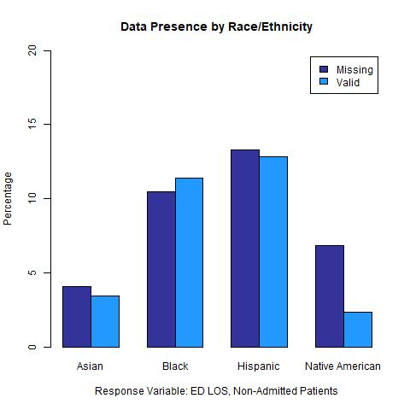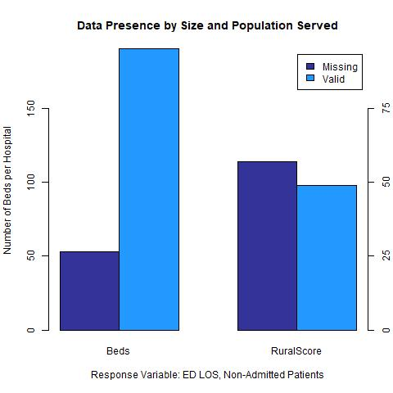

**FIGURE A-3: Rates of Missing Data for *NonAdmitLOS***

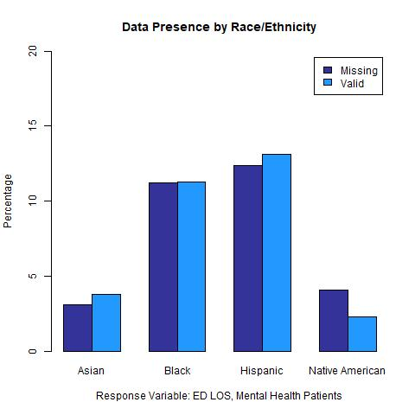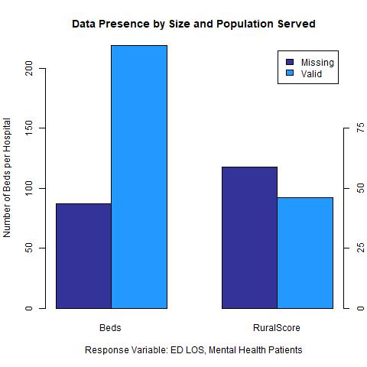

**FIGURE A-4: Rates of Missing Data for *MHLOS***

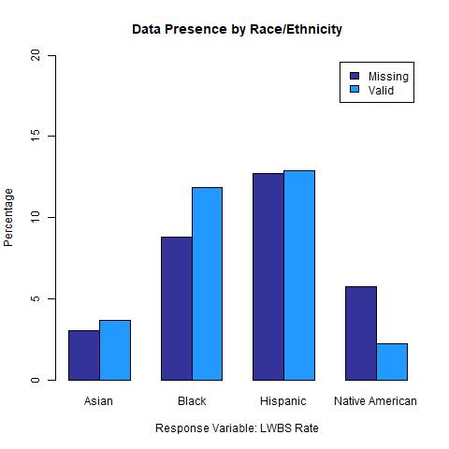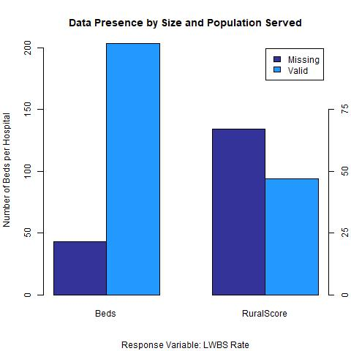

**FIGURE A-2: Rates of Missing Data for *LWBSrate***